**Plots and Analysis**

**Question 1:** Job satisfaction comes with more salary compensations/expectations?

**Code:**

#installs necessary packages

install.packages("ggpubr")

install.packages("dplyr")

library(ggplot2)

#question 1

#plots job satisfaction with salary in dollars, “las = 2” displays they x-axis labels vertically

plot(data$JobSatisfactionNumeric,data$ConvertedSalary, las =2)

#tests for correlation between the variables

cor.test(data$JobSatisfaction,data$ConvertedSalary)

**Plot:**

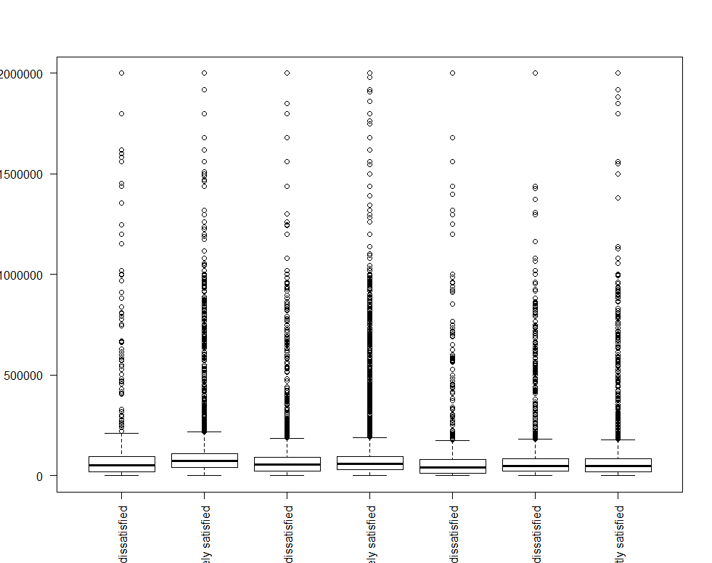

**Question 2:** If large Multinational Corporations want to offshore their workload, which countries can be suitable in terms of logistics (SALARY, JOB EXPECTATION, YEARS OF EXPERIENCE) and workforce?

**Code:**

#similar to the code above. Plotting the two variables together

plot(data$JobSatisfactionNumeric,data$ConvertedSalary, las =2)

#testing for corrolation

cor.test(data$JobSatisfaction,data$ConvertedSalary)

#testing for correlation for Job satisfaction and years coding as a profession

cor.test(data$JobSatisfaction,data$YearsCodingProf)

#plots the two varibles

plot(data$JobSatisfactionNumeric,data$YearsCodingProf, las = 2)

cor.test(data$YearsCodingProf)

**Plot:**



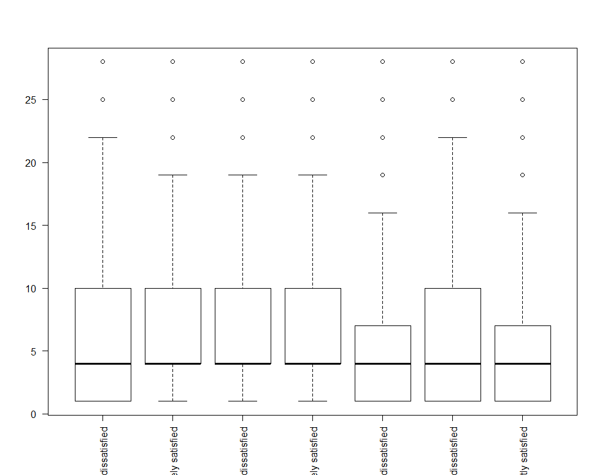

**Question 3:** Does location affect the skillsets and technical expertise?

**Code:**

#question 3

#saves column to variable 'country'

country = dataframe$Country

#saves column to variable 'langknown'

langknown = dataframe$Number_of_languages_known

#creates a new dataframe with only the two columns

df <- data.frame(country, langknown)

df

#aggregates the dataframe and cacluates mean based on the country

df2 = aggregate(.~country, data=df, mean)

#there a re a lot of countries so it fills up the x-axis

#this eliminates the ones less than 9

dataframe_1 <- subset(df2,df2$langknown > 9)

dataframe_1

#use xyplot to plot the new dataframe

library(lattice)

xyplot(dataframe_1$langknown~dataframe_1$country, xlab = "Country", ylab = "Average Number of Languages Known")



**Question 4 :** Does the number of years in a job affect the workers’ willingness to switch?

**Code:**

#question 4

#eliminates all NA values

na.omit(dataframe$YearsCodingProf)

#plots Years coding against Job search status

plot(dataframe$YearsCodingProf ~ dataframe$JobSearchStatus)



**Question 5:** To check stability in a person based on years of work, competencies, age, salary and last switch to

control attrition.

**Code:**

#Here we find the relationshoip and corelation between the people having a shift from last job to the latest job and their years of professional coding experience. A moderate positive relation between these determine that the predictor and response variable are correlated and affected positively.

plot(data$LastNewJob,data$YearsCodingProf)

cor.test(data$LastNewJob,data$YearsCodingProf)

#Here we find the relationshoip and corelation between the people having a shift from last job to the latest job and salary. Since the value of correlation is 0 there exists no relation between the predictor and response variable are correlated and affected positively.

plot(data$LastNewJob,data$ConvertedSalary)

cor.test(data$LastNewJob,data$ConvertedSalary)

#Here we find the relationshoip and corelation between the people having a shift from last job to the latest job and their age. A moderate positive relation between these determine that the predictor and response variable are correlated and affected positively.

plot(data$LastNewJob,data$Age)

cor.test(data$LastNewJob,data$Age)

**Plot:**

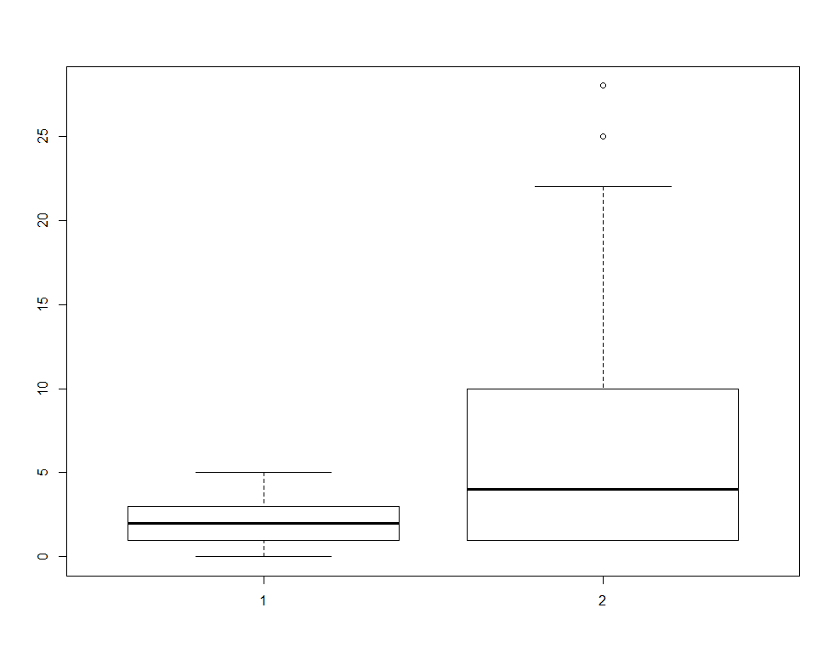

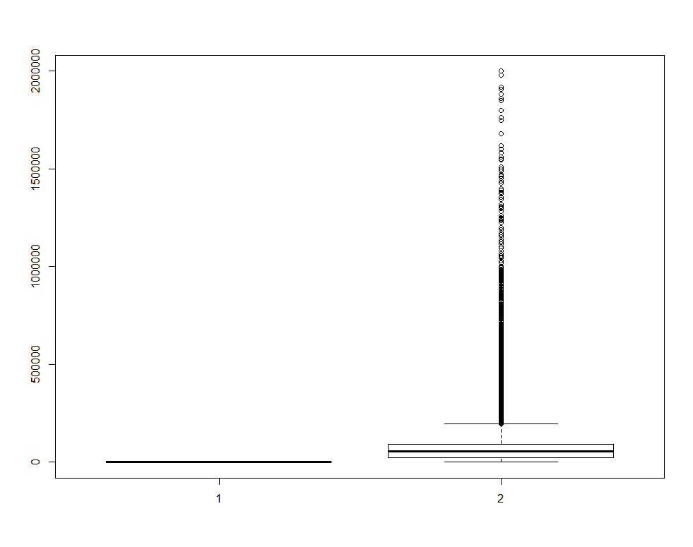

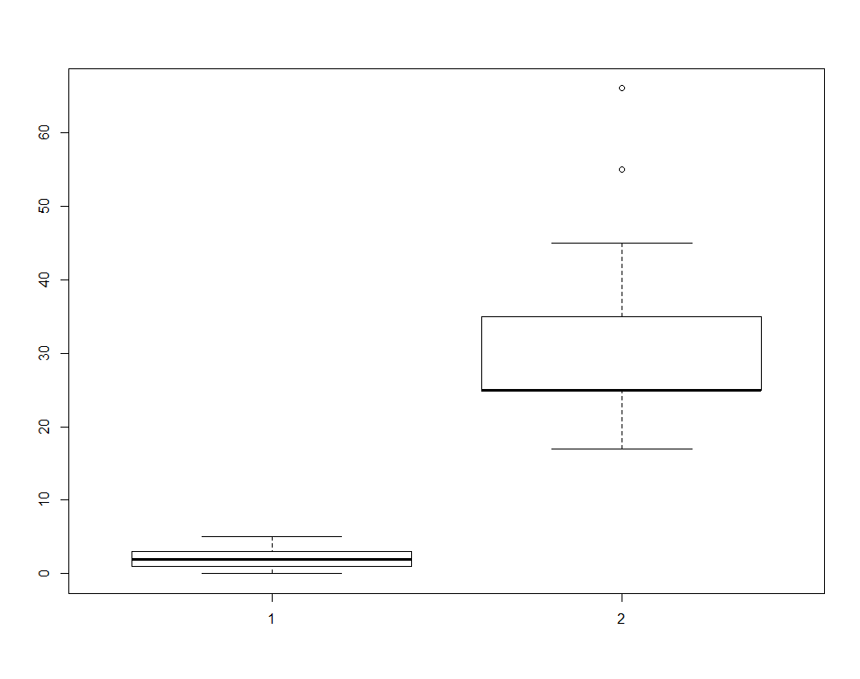

**Question 6**: Do people use sites like stack overflow to find new jobs?

**Code:**

#for question 6

#plots a histogram of the binary answeres for the column StackOverflowJobs

plot(dataframe$StackOverflowJobs)

**Plot:**



**Word Count: 444**